*Enhancing Investment Decisions: Technical Indicator-Driven Stock Price Predictions*

***Of***

**BACHELOR OF ENGINEERING**

**Information Technology**

Submitted by

|  |
| --- |
| 11 Pranav Bhavsar  12 Bharat Bohra |

***Under the Guidance of***

**Mrs. Pranjali Kasture**

Assistant Professor

**Department of Information Technology**

**(Academic Year. 2023-24)**



**Information Technology**

**Thakur College of Engineering & Technology**

Thakur Village, Kandivali (East), Mumbai-400101

**(Academic Year 2023-24)**

**CERTIFICATE**

This is to certify that the project entitled **“*Enhancing Investment Decisions: Technical Indicator-Driven Stock Price Predictions”*** is a bonafide work of ***Mr.Pranav Bhavsar (Roll No.:11) , Mr. Bharat Bohra (Roll No.:12)*** submitted to the Thakur College of Engineering and Technology, Mumbai (An Autonomous College affiliated to University of Mumbai) in partial fulfillment of the requirement for the award of the degree of **“Bachelor of Engineering”** in **Information Technology**

|  |  |
| --- | --- |
| Signature with Date: -----------------  Pranjali Kasture.:  Assistant Professor.: | Signature with Date: --------------------  Dr. Rajesh S Bansode  Information Technology: |

Date:

Place: Mumbai

**ABSTRACT**

**ACKNOWLEDGEMENT**

We sincerely thank to our **Mrs. Pranjali Kasture** for her guidance and support for carrying out our project work.

We express our heartfelt gratitude to our esteemed Principal for his unwavering support and encouragement throughout the duration of our project. We extend our sincere appreciation to the Dean for his invaluable guidance and mentorship. Special thanks to our Head of Department for his constant support and motivation.

We are deeply indebted to our project guide Mrs. Pranjali Kasture for her expert advice, patience, and continuous encouragement, which greatly contributed to the success of our project. We also extend our gratitude to the industry experts whose insights enriched our work.

We would like to thank our colleagues for their collaboration and assistance. Last but not least, we extend our heartfelt appreciation to our parents for their unwavering support and encouragement throughout this journey.

Without the support of these individuals, our project would not have been possible.

Pranav Bhavsar (11)

Bharat Bohra (12)

**CONTENTS**

Abstract

Acknowledgement

**Chapter 1.** LinkedIn Profile and Blog Writing

1.1 LinkedIn Profile Screenshots ....................................................................................

1.2 Blog Screenshots …..……………………………………………………………

1.3 URL (LinkedIn Profile/ Blog)………………………………………………………

1.4 Count of Likes, Shares and Comments

1.5 Screenshots of Quiz

1.6 Rubrics

**Chapter 2.** Prototype Development

2.1 Screenshots of Prototype Development................................................................................

2.2 Tool Description....................................................................................................................

2.3 Screenshots of Quiz

2.4 Rubrics

**Chapter 3.** Mathematical Modelling and Infographics

3.1 Description of Mathematical model used………………………………………………..

3.2 Usage of Mathematical model in the project…………………………………………….

3.3 Infographics…………………………………………………………………………….

3.4 Screenshots of Quiz

3.5 Rubrics

**Chapter 4.** Research Paper

4.1 Screenshot of Research Paper Presentation…………………………………………..

4.2 Research paper………………………………………………………………………

4.3 Screenshots of Quiz

4.4 Rubrics

**Chapter 5.** Outside Participation certificates (if any)

5.1 Certificate (Screenshot)

5.2 Rubrics

**Chapter 1: LinkedIn Profile and Blog Writing**

**1.1 LinkedIn Profile Screenshots**

 

**1.2 Blog Screenshots**

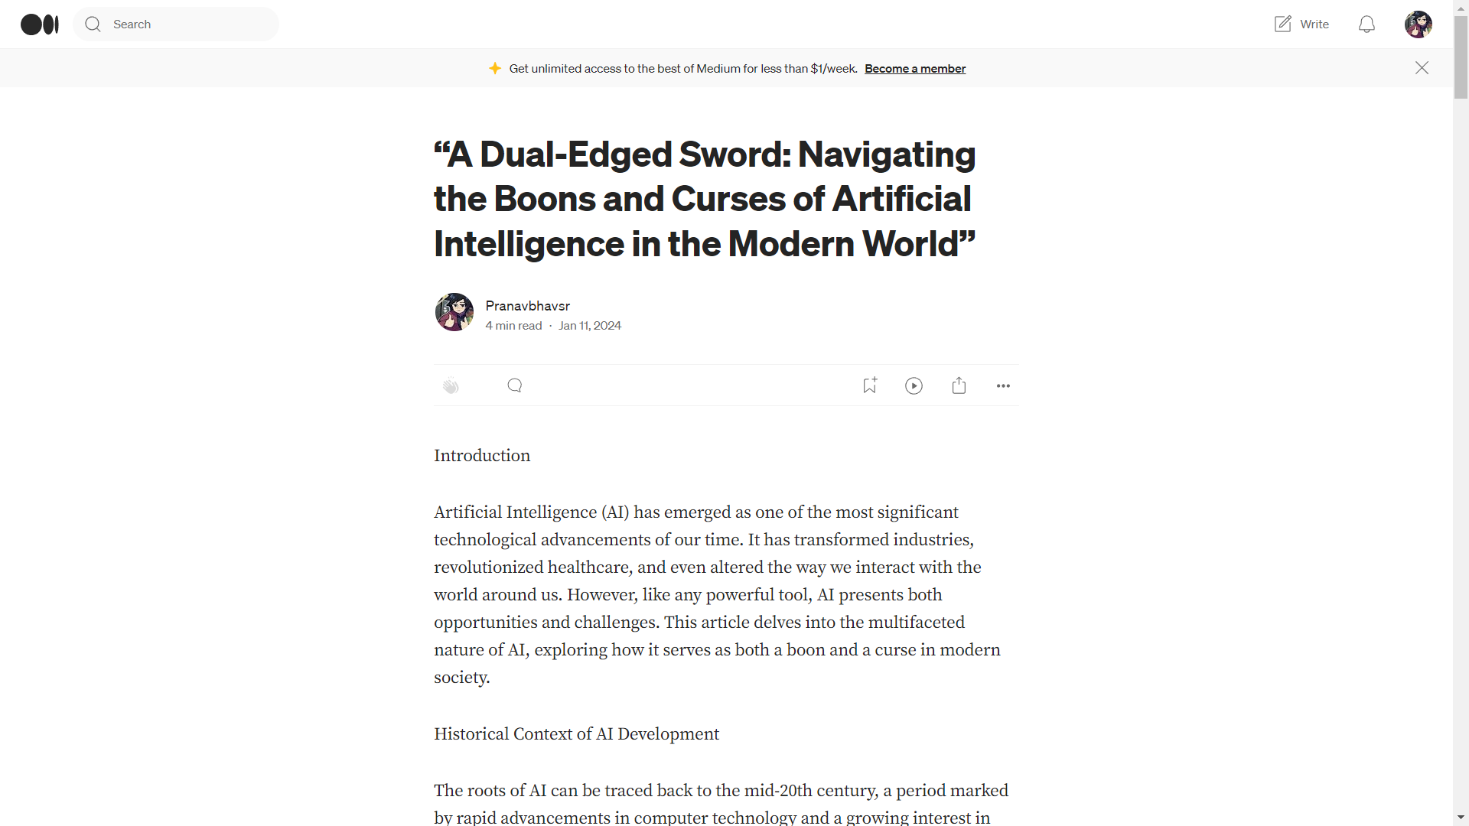

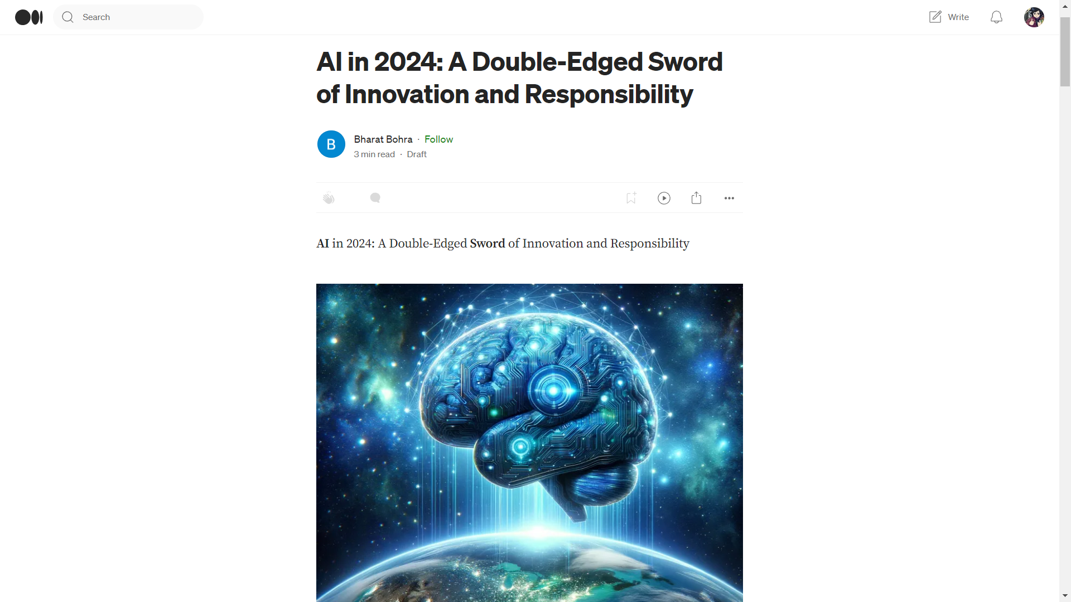

**1.3 URL (LinkedIn Profile/ Blog)**

|  |
| --- |
| **Pranav Bhavsar.:** [**https://www.linkedin.com/in/pranav-bhavsar-554b8a225/**](https://www.linkedin.com/in/pranav-bhavsar-554b8a225/) |
| **Blog link.:** [**https://medium.com/@pranavbhavsr2003/a-dual-edged-sword-navigating-the-boons-and-curses-of-artificial-intelligence-in-the-modern-c7a028da5bef**](https://medium.com/@pranavbhavsr2003/a-dual-edged-sword-navigating-the-boons-and-curses-of-artificial-intelligence-in-the-modern-c7a028da5bef) |
| **Bharat Bohra.:** [**https://www.linkedin.com/in/bharat-bohra-760b43222/**](https://www.linkedin.com/in/bharat-bohra-760b43222/) |
| **Blog link.:** [**https://medium.com/@bharatbohra07/597651e7a550**](https://medium.com/@bharatbohra07/597651e7a550) |

**1.4 Count of Likes, Shares and Comments’**

**1.5 Rubrics Blog writing and LinkedIn Profile building**

|  |  |  |  |  |
| --- | --- | --- | --- | --- |
| **Parameter** | **Excellent** | **Very good** | **Good** | **Average** |
| **20** | **15** | **10** | **5** |
| **Content and Creativity** | Content provides comprehensive insight, understanding, and reflective thought about the topic by building a focused argument around a specific issue or  asking a new related question or  making an oppositional statement supported by personal experience or related research. | Content provides moderate insight, understanding and reflective thought about the topic. | Content provides minimal insight, understanding and reflective thought about the topic. | Content shows no evidence of insight, understanding or reflective thought about the topic. |
| **GA2** |
| **Text Layout, Use of Graphics and Multimedia** | Selects and includes high quality graphics and multimedia when appropriate to enhance the content’s visual appeal and increase readability. | Selects and includes graphics and multimedia that are mostly high quality and enhance and clarify the content. | Selects and includes many low-quality graphics and multimedia which do not enhance the content. | Does not include any graphics, or uses only low-quality graphics and multimedia, which do not enhance the content. |
| **GA5** |
| **Quality of Writing and Proofreading** | Written content is free of grammatical, spelling or punctuation errors. The style of writing facilitates communication. | Written content is largely free of grammatical, spelling or punctuation errors. The style of writing generally facilitates communication. | Written content includes some grammatical, spelling or punctuation errors that distract the reader. | Written content contains numerous grammatical, spelling or punctuation errors. The style of writing does not facilitate effective communication. |
| **GA10,GA7** |
| **Citations** | All images, media and text created by others display appropriate copyright permissions and accurate citations. | Most images, media or text created by others display appropriate copyright permissions and accurate, properly formatted citations. | Some of the images, media or text created by others does not display appropriate copyright permissions and does not include accurate, properly formatted citations. | No images, media or text created by others display appropriate copyright permissions and do not include accurate, properly formatted citations. |
|  |
| **Publication of blog** | The blog is posted on student's host site. | The blog is posted on free blog site. | The blog is made into a web page. | The blog is not posted. |
| **GA12** |
| **Likes, Shares and Comments on the blog GA06** | The blog has all three of the following: Likes, shares and comments. | The blog has any two of the following: Likes, shares and comments. | The blog has received only one of the following: Likes, shares and comments. | The blog has not received either of the following: Likes, shares and comments. |

**Chapter 2: Prototype Development**

**2.1 Screenshots of Prototype Development**

**2.2 Tool Description**

**2.3 Rubrics Prototype Development**

|  |  |  |  |  |
| --- | --- | --- | --- | --- |
| **Parameter** | **Excellent**  **(20)** | **Very Good**  **(15)** | **Good**  **(10)** | **Average**  **(05)** |
| **Identifying Type of Prototype (Visual prototype/Functional prototype /Presentation prototype)**  **(GA3)** | Functional Prototype | Presentation prototype | Visual Prototype with little functions | Only Visual prototype |
| **Advantages of prototyping**  **GA4** | Identification of innovative design thinking-based approach to make a prototype which is easy to implement and cost effective  Interdisciplinary knowledge is applied | Identification of innovative approach to make a prototype | Try existing methods with slight modification to make a prototype | Apply existing methods and solution as it is to make a prototype |
| **A step-by-step break-down of prototyping**  **GA4,GA5** | Apply latest Tools and technology | Apply latest Tools and technology learned in academics | Application of old techniques with slight modification | Application of old tools and techniques |
| **The Spiral model**  **GA8,GA10** | Review and plan for next phase  Use of own design | Develop next version of product  Use of existing design | Objective determination and identify alternative solutions | Identify and resolve risks |
| **Conclusion**  **GA 11** | (A)Clarify its purpose, function and appearance+(B)+( C) +(D)  Use of project management tools and knowledge to conclude | (B) Improve user experience and marketability)+( C) +(D) | ( C )Explore its manufacturability and make-up+(D) | (D) Solve problems before they occur |

**Chapter 3: Mathematical Model and Infographics**

**3.1 Description of Mathematical model used**

**3.2 Usage of Mathematical model in the project**

**3.3 Infographics**

**3.4 Rubrics Mathematical Model and Infographics**

|  |  |  |  |  |
| --- | --- | --- | --- | --- |
| **Marks** | **20** | **15** | **10** | **5** |
| **Parameter** | **Excellent** | **Very Good** | **Good** | **Average** |
| **Statement of Problem in real world** | Students are able to identify the real-world problem that can be represent in specific mathematical model | Students are able to identify the real-world problem that can be represent in general mathematical model | Students are able to identify the real-world problem that can be represent in abstract mathematical model | Students are able to identify the real-world problem that can be represent in poor mathematical model |
| **Technicality** | Students are able to identify clear and specific mathematical variables (parameters) | Students are able to identify generalized mathematical variables (parameters) that will be directly or indirectly influenced | Students are able to identify abstract mathematical variables (parameters) that will be directly or indirectly influenced | Students are able to identify barely relevant mathematical variables (parameters) |
| **Design and Formulation of Model** | It completely enables the construction of a mathematical model using of tools required for mathematical modelling and simulation | It enables the construction of a mathematical model use of some tools required for mathematical modelling and simulation | It enables the construction of a mathematical model use of a few tools required for mathematical modelling and simulation | It enables the construction of a mathematical model without using tools required for mathematical modelling and simulation. |
| **Presentation and Team Work** | Student demonstrates full knowledge, answering all queries with explanations through the attractive infographics. | Student demonstrates partial knowledge, answering some of queries with explanations through the very good infographics. | Student is able to answer only basic queries utilization good infographics. | Student have poor knowledge; they are able to answer only few queries utilization poor infographics. |
| **Evaluation of the Mathematical Model** | Mathematical model is able to represent exact behaviour of real world problem identified and same is reflected using infographics | Mathematical model is able to represent similar behaviour of real world problem and same is reflected using infographics | Mathematical model is able to represent relevant behaviour of real world problem and same is reflected using good infographics | Mathematical model is able to represent irrelevant behaviour of real world problem and same is reflected using poor infographics |

**Chapter 4: Research Paper**

**4.1 Screenshot of Research Paper Presentation**

**4.2 Research paper**

**4.3 Rubrics**

|  |  |  |  |  |  |  |
| --- | --- | --- | --- | --- | --- | --- |
| **Sr. No** |  | **Question** | **Marks (20)** | **Marks (15)** | **Marks (10)** | **Marks (05)** |
| **Excellent** | **Very Good** | **Good** | **Poor** |
| **1** | **Organization of Content** | **Do research paper is organised with proper sections and relevant content ?** | If paper includes all heads including:  1) abstract,  2) introduction,  3)objectives,  4)methodology,  5)experimental plan,  6)result and discussion, 7) conclusions,  8)future scope. 9)References | If paper includes any 8 topics out of  1) If paper includes any 7 topics out of  1) abstract  2) introduction,  3)objectives,  4)methodology, 5)experimental plan,  6)result and discussion, 7)conclusions,  8)future scope. 9)References | If paper includes any 6-7 topics out of 1) abstract,  2) If paper includes any 5-6 topics out of 1) abstract,  2) introduction,  3)objectives,  4)methodology,  5)experimental plan,  6)result and discussion, 7) conclusions,  8)future scope. 9)References | If paper includes any 5 topics out of  1) abstract,  2) introduction,  3)objectives,  4)methodology,  5)experimental plan,  6)result and discussion, 7) conclusions,  8)future scope. 9)References |
| **2** | **Correct Content with respect to Grammar and language** | Do the research paper written in scientific language which clearly define the research work done? | The writing is Compelling.  Sentences are well-phrased and varied in length and structure. Content are grammatically correct. Word choice is consistently  precise and accurate. | The writing is generally engaging, but has some dry  spots. Sentences are well phrased and there is some variety in length and structure.  Word choice is  generally good. | The writing is dull and un engaging.  Some sentences are awkwardly  Constructed so that the reader is occasionally distracted.  Word choice is merely  adequate, and the range of words is limited. | The writing loses interest in the reader.  Errors in sentence  structure are frequent enough to be a major distraction to the reader. Many words are used inappropriate |
| **3** | **Design, Development and  Implementation** | Does research paper have proposed model, flowcharts, results of implementation and analysis? | All 4 parameters met:  1) Modern Tool Usage  2) Feasibility  3)User friendliness  4)Application | Any 3 parameters met:  1) Modern Tool Usage  2) Feasibility  3)User friendliness   4)Application | Only 2 parameters met:  1) Modern Tool  Usage 2) Feasibility  3) User friendliness  4)Application | Only 1 parameter  met:  1) Modern Tool  Usage  2) Feasibility  3)User friendliness  4)Application |
| **4** | **Presentation and Team Work** | Does paper presentation team exhibit communication skill and co-operation while giving presentation? | • Student  demonstrates full  knowledge,  answering all  queries with  explanations.  • Movements seem smooth and help the audience  visualize.  • Diverse talents are present in team with different skill set | • Student is at ease with information and answers all queries without elaboration.  • Made movements or gestures that enhance articulation.  • Team is concentrated with only one type of skill set. | • Student is  Uncomfortable with  information and is able to answer only basic queries.  • Very little  movement or descriptive  gestures. • Team members are not contributing much for multifaceted development of idea | • Student does not have grasp of  Information and can’t answer  queries about subject.  • No movement or descriptive gestures.  • Team  members are passive • only one person is taking some efforts |
| **5** | **Qualification towards Quality of Paper and research claims** | Does the research paper have novelty, mathematical models, result and with proper conclusion consisting of project claim with proper verification, validation, and diagnostics? | Paper has novelty, mathematical models, result and its analysis with proper conclusion consisting of project claim with proper verification, validation, and diagnostics? | Paper has 1) novelty,2) mathematical models, 3) Research claim and result analysis with some diagrammatic representation | Paper has 1) novelty,2) mathematical models, 3)result analysis without any validation and verification | Paper has: 1) novelty, 2) mathematical models, 3)result analysis and claim is not clear. |
|  | **Note:** | Examiner can put √ (Tick) wherever applicable and put X (cross) if not applicable | | |  |  |
|  | **Overall Remark** | (Review Paper/Technical Paper/Poster/Case Study) | | | | |
|  | **Name and Signature of Evaluator:** | |  |  |  |  |

**Chapter 5. Outside Participation certificates**

**5.1 Certificate(Screenshot)**

**5.2 Rubrics**

|  |  |  |  |  |
| --- | --- | --- | --- | --- |
| **Parameter** | **Excellent**  **(20 Marks)**  **100 %** | **Very Good**  **(15 Marks)**  **75 %** | **Good**  **(10 Marks)**  **50 %** | **Average**  **(05 Marks)**  **25 %** |
| Problem Identification  GA 2 | Insightful and in-depth background information is provided to illuminate the issues through inclusion of:  • history relevant to the presentation, the “big picture”  • a succinct description of the significance of the project | Background information is provided, including references to the work of others and an explanation of why the project was undertaken, to help put the presentation in context. | Little background information is presented using relevant references to help the audience understand the history and significance of the project. | Very little or no background information is presented to help the audience understand the history and significance of the project. |
| Content  GA 4 | • Addresses all specified content areas.  • Material abundantly supports the topic.  • Use of engineering terms and jargon matches audience knowledge level. | • Addresses most content areas.  • Material sufficiently supports the topic.  • Use of engineering terms and jargon mostly matches audience knowledge level. | • Addresses some of the content areas.  • Material minimally supports the topic.  • Use of engineering terms and jargon minimally matches audience knowledge level. | • Addresses few of the content areas. • Material does not support the topic.  • Use of engineering terms and jargon does not match audience knowledge level. |
| Visuals  GA4,GA5 | • Use of prezi or advance tools  Text is easily readable.  • Graphics use constantly supports the presentation.  • Slide composition has a professional look that enhances the presentation | •Use of Powerpoint presentation  Text is readable. • Graphics use mostly supports the presentation. • Slide composition is not visually appealing, but does not detract from the presentation | • Text is readable with effort.  • Graphics use rarely supports the presentation. • Slide composition sometimes distracts from the presentation | • Text is not readable.  • Graphics use does not support the presentation. • Slide composition format is clearly distracting, obscuring the presentation |
| Presentation Skills  GA 7 | • Clearly heard and polished.  • Attitude indicates confidence and enthusiasm.  • Audience attention is constantly maintained. | • Clearly heard but not polished. • Attitude indicates confidence but not enthusiasm.  • Audience attention is mostly maintained. | • Difficult to hear and/or moments of awkwardness. • Attitude indicates some lack of confidence and/or disinterest in subject.  • Audience attention is minimally maintained | • Inaudible; several awkward pauses.  • Attitude indicates lack of confidence and/or disinterest in subject.  • Audience attention is not maintained |
| Participation level  GA 12 | International / National | State | District / Local | Institute |